**2022 йил 4 ноябрь, 2023, Тошкент**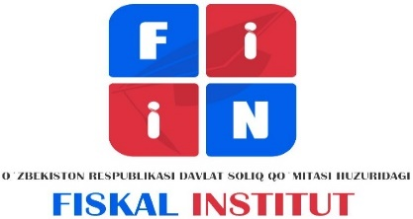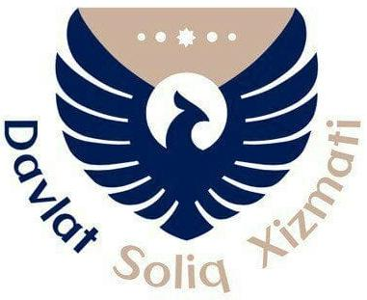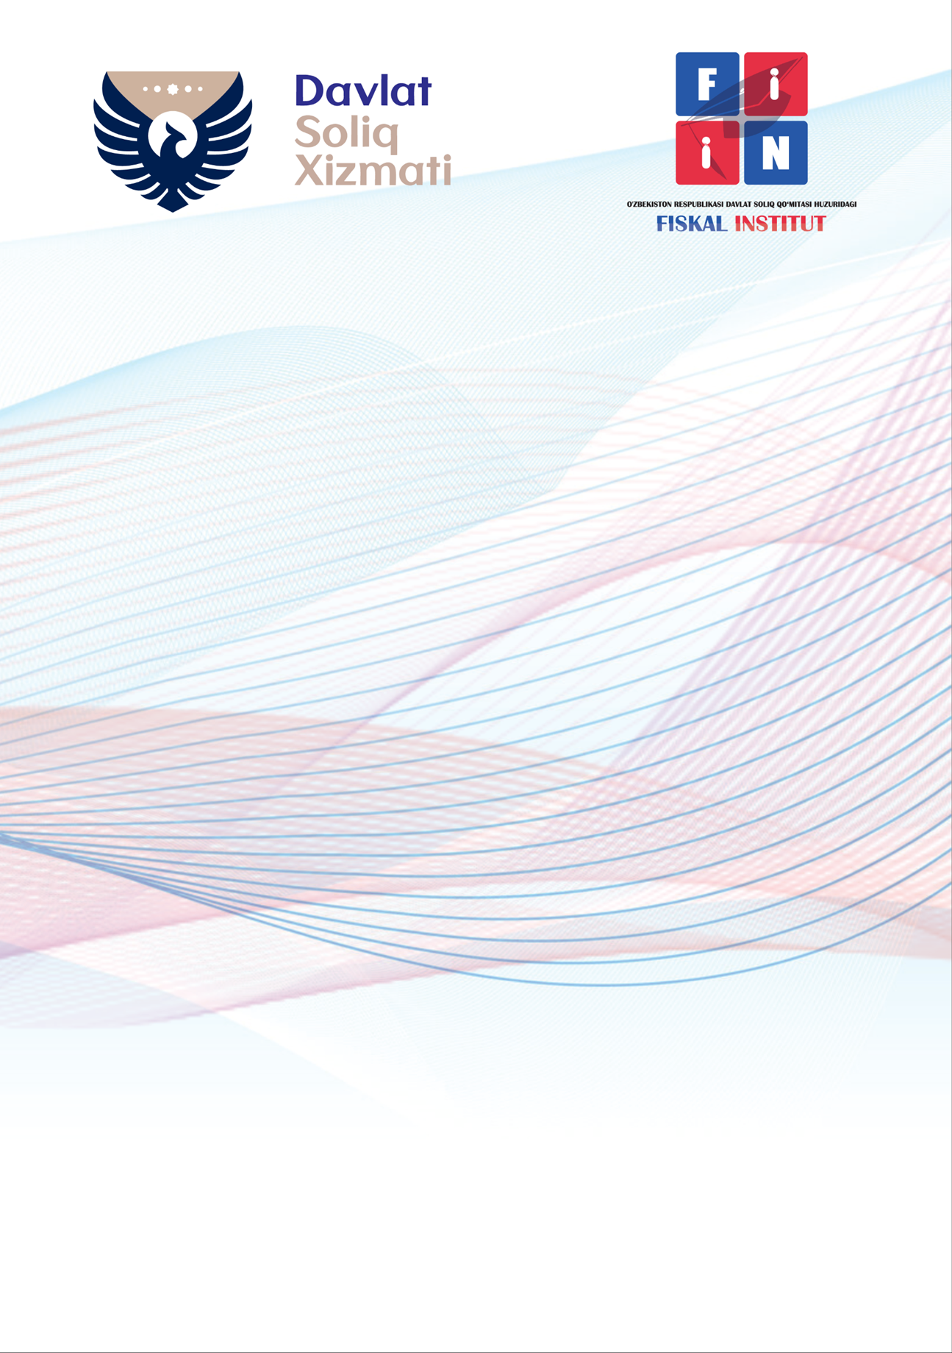

**ЎЗБЕКИСТОН РЕСПУБЛИКАСИ ДАВЛАТ СОЛИҚ ҚЎМИТАСИ**

**СОЛИҚ ҚЎМИТАСИ ҲУЗУРИДАГИ ФИСКАЛ ИНСТИТУТ**

**ХАЛҚАРО КОНФЕРЕНЦИЯ**

**Фискал сиёсат ва солиққа тортиш механизмини такомиллаштиришда халқаро тажрибадан фойдаланишдаги масалалар**

**2023 йил 30 октябр - 4 ноябр, Тошкент**

**ТАКЛИФНОМА**

**INTERNATIONAL CONFERENCE**

**International Experience in Improving Fiscal Policy and Taxation Mechanism**

**2023, October 30th - November – 4th, Tashkent, Uzbekistan**

**INVITATION**

**МЕЖДУНАРОДНАЯ КОНФЕРЕНЦИЯ**

**Международный опыт в совершенствовании фискальной политики и механизма налогообложения**

**2023, 30 октября - 4 ноября, Ташкент, Узбекистан**

**ПРИГЛАШЕНИЕ**

The Fiscal Institute under the Tax Committee of the Republic of Uzbekistan is pleased to invite tax, accounting and finance professionals to the Conference “**International Experience in Improving Fiscal Policy and Taxation Mechanism**”. Our Conference aims at presenting and discussing the most interesting tax, accounting and finance policy issues. Representatives of the fiscal authorities, practitioners and academicians from different countries are welcome to join the conference.

The main topics will deal with:

● Domestic Tax Policy (including taxation and tax administration)

● BEPS-related Agenda (BEPS Action Plan and BEPS 2.0)

● Tax Treaty Issues

● Tax Integration Process

● Taxation of New Economy

● Tax and Finance Law Theory

● Accounting in Modern Economy

● Empirical Methods in Tax Policy Evaluation Research

The scientific results of the conference will be published in the conference proceedings.

The working sessions will be held all day on November 1 – November 3**. The International Taxation Winter School** and **the International Taxation Moot Court** are integrated parts of the conference.

The detailed conference program (Including the International Taxation Winter School and the International Taxation Moot Court) will follow.

Mostly sessions will be held in English but selected sessions may be done in Uzbek or Russian. There will be a separate session for students (in English, Uzbek or Russian).

There is no participation fee for the working sessions of Conference. Lecturers and Students of the International Taxation Winter School, participants, trainers and judges of the International Taxation Moot Court will be provided with living at the Institute campus.

If you are interested to participate, please fill out the online registration form as soon as possible. (https://fiin.uz/conference-registration)

If you have any questions, please contact [ziyat.qurbanov@soliq.uz](mailto:ziyat.qurbanov@soliq.uz)

**The Fiscal Institute under the State Tax Committee of the Republic of Uzbekistan**

|  |  |
| --- | --- |
| **Yusupov Kakhramon Akhmedovich**  First Vice Rector for Strategic Development  Phone number:+998 71 230-16-31  fiskal@soliq.uz | **Akbaraliev Bakhtiyorjon Bakirovich**  First Vice Rector forAcademic Affairs  Phone number:+998 71 230-16-29  fiskal@soliq.uz |

fiin.uz +998 71-230-16-50, 100173, Tashkent, Uchtepa district, Kichik Xalqa yoli, 3